Network Intrusion Detection for Cyber Security using KNN

Project Id: AIML- 09

Student Name: ASMITA (TEAM LEADER)
University Roll number: 2028676
Section: U

Student Name: NEHA NEGI
University Roll number: 2028455
Section: U

Student Name: ADITI SHARMA
University Roll number: 2028618
Section: U

TABLE OF CONTENTS

- Problem Description………………………………………………………….3
- Architecture ………………………………………………………………….4-5
- Models model………………………………………………………………….6
- Evaluation metrics used………………………………………………………7
- Preliminary Results and Visualizations…………………………………….8-9
- References……………………………………………………………………..10

- Problem Description

In today’s digital world, cyber security has become an important requirement for protecting computer networks and sensitive information. Organizations continuously exchange large amounts of data through networks, which increases the chances of cyber attacks such as unauthorized access, malware attacks, and suspicious activities. Monitoring such huge network traffic manually is difficult and time-consuming.

The main aim of this project is to develop a Machine Learning based Network Intrusion Detection System that can automatically identify malicious network traffic and distinguish it from normal traffic. The project uses different machine learning techniques to analyze network behavior using features such as:
Packet_Size, Connection_Duration, Error_Rate, Source_Bytes, Destination_Bytes,etc.

The dataset used in this project is collected from Kaggle and contains network traffic records labeled as normal or malicious. Different machine learning models are implemented and compared to identify the model that gives the best prediction accuracy.
The project includes:
- Data preprocessing
- Feature scaling
- Feature selection
- Model training
- Hyperparameter tuning
- Performance evaluation
- Data visualization

Machine learning models used in this project are:
- Logistic Regression
- K-Nearest Neighbors (KNN)
- Decision Tree
- Random Forest
- Support Vector Classifier (SVC)

The final system helps in improving cyber security by automatically detecting intrusions efficiently and accurately.

- FLOW DIAGRAM

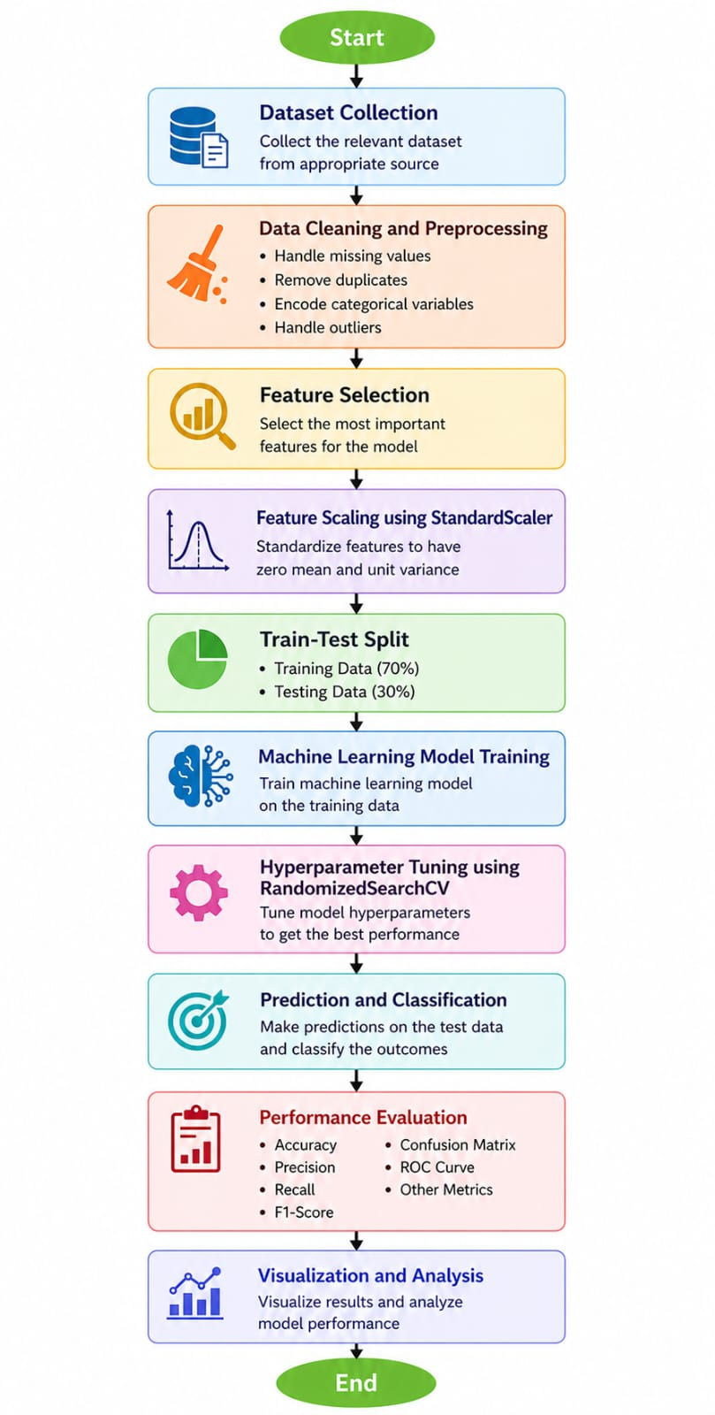

Fig.1 Machine Learning Workflow
Architecture Explanation
1. Dataset Collection
The dataset is collected from Kaggle. It contains information related to network traffic behavior.

2. Data Selection
Only important features required for intrusion detection are selected to reduce complexity and improve efficiency.

3. Data Preprocessing
The dataset is cleaned by handling missing values, removing duplicates, and organizing the data into a suitable format.

4. Feature Scaling
StandardScaler is applied to normalize feature values because KNN is sensitive to feature ranges.

5. Train-Test Split
The dataset is divided into training and testing datasets to evaluate model performance on unseen data.

6. KNN Model Training
The KNN algorithm classifies data based on nearest neighbors and learns patterns from the training dataset.

7. Hyperparameter Tuning
RandomizedSearchCV is used to find the best parameters such as:
- Number of neighbors
- Distance metric
- Weight type

8. Elbow Method
The Elbow graph helps in selecting the optimal value of K for better prediction accuracy.

9. Performance Evaluation
The model predictions are evaluated using multiple metrics to measure detection performance.

- Models Used(Applied/ Planned)

1. Logistic Regression
Logistic Regression is a supervised machine learning algorithm used for binary classification problems. It predicts whether network traffic is normal or malicious using probability values.
Advantages
- Fast and efficient
- Easy to understand
- Suitable for binary classification

2. K-Nearest Neighbors (KNN)
KNN classifies data based on the nearest neighboring data points using distance calculations.
Advantages
- Simple implementation
- Effective for pattern recognition
- Suitable for intrusion detection

3. Decision Tree
Decision Tree creates a tree-like structure for decision making and classification.
Advantages
- Easy visualization
- Understandable rules
- Fast prediction process

4. Random Forest
Random Forest combines multiple decision trees to improve prediction accuracy and reduce overfitting.
Advantages
- High accuracy
- Better generalization
- Reduces overfitting

5. Support Vector Classifier (SVC)
Support Vector Classifier separates classes using an optimal hyperplane.
Advantages
- Effective for classification tasks
- Handles high-dimensional data
- Provides strong prediction accuracy

- Evaluation metrics used

1. Accuracy
Accuracy measures the overall correctness of model predictions.
Formula
Accuracy = Correct Predictions / Total Predictions

2. Precision
Precision measures how many predicted attacks are actually correct.
Formula
Precision = TP / (TP + FP)

3. Recall
Recall measures how many actual attacks are correctly detected.
Formula
Recall = TP / (TP + FN)

4. F1-Score
F1-score balances precision and recall.
Formula
F1-score = 2 × (Precision × Recall) / (Precision + Recall)

5. Confusion Matrix
Confusion matrix displays:
- True Positives
- True Negatives
- False Positives
- False Negatives
It helps in understanding prediction performance clearly.

5. Preliminary Results and Visualizations

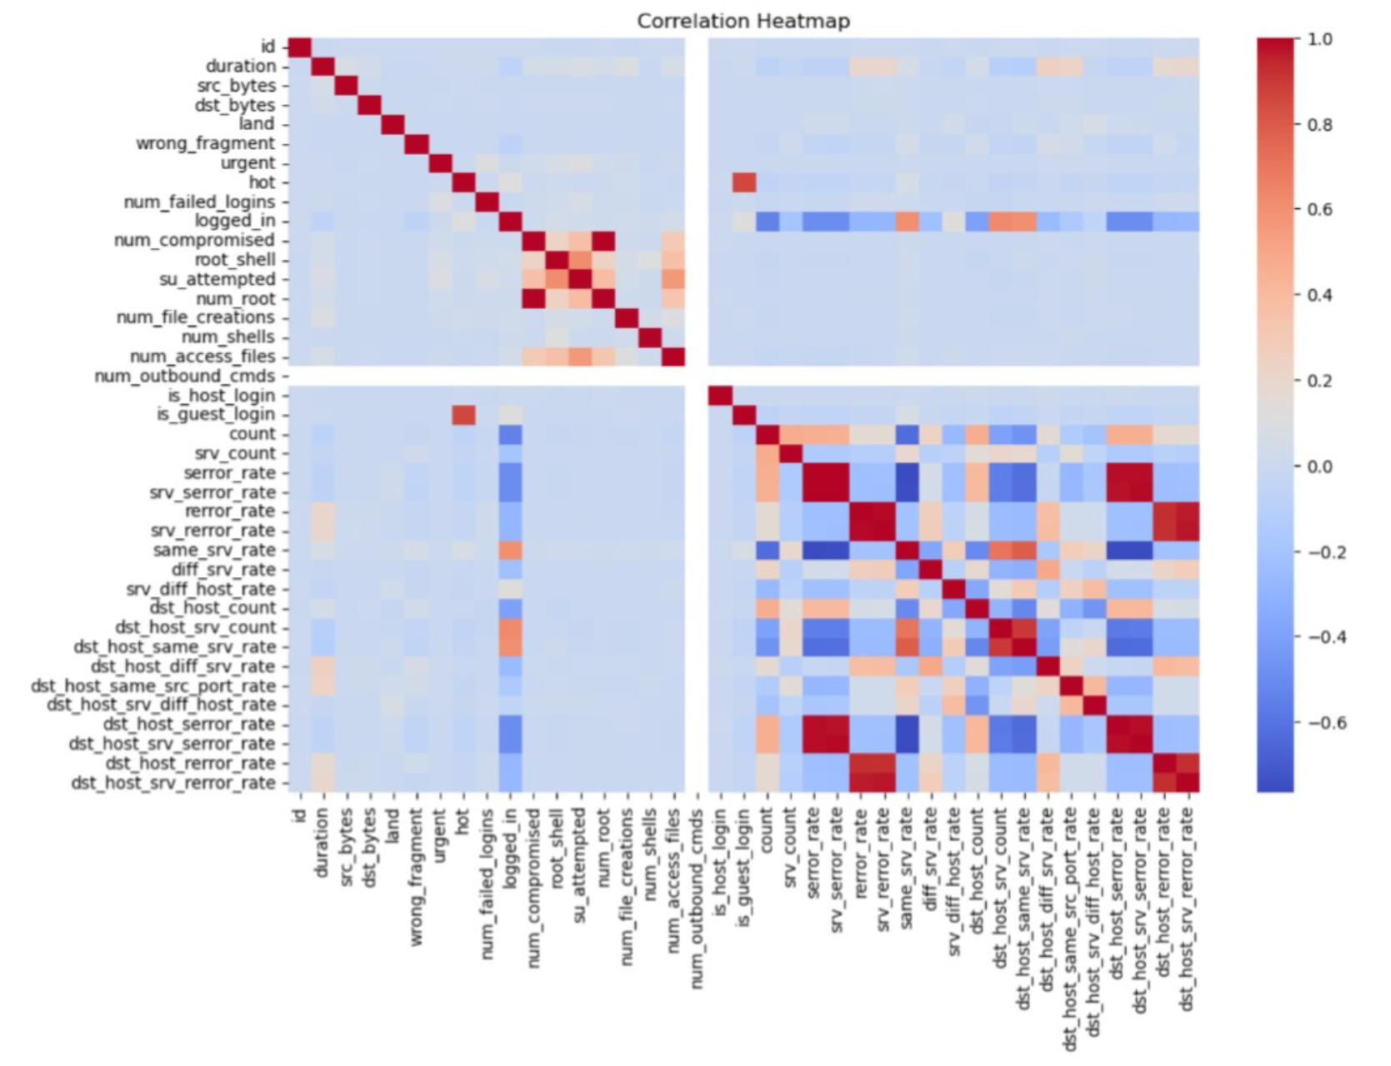

FIG 1: CORRELATION OF HEATMAP

The correlation heatmap visualizes relationships among numerical features in the intrusion detection dataset. Red regions indicate strong positive correlation, blue regions indicate negative correlation, and light colors show weak relationships. Several traffic and error-rate features exhibit high correlation, which helps identify important network behavior patterns useful for attack detection and feature selection in machine learning models.
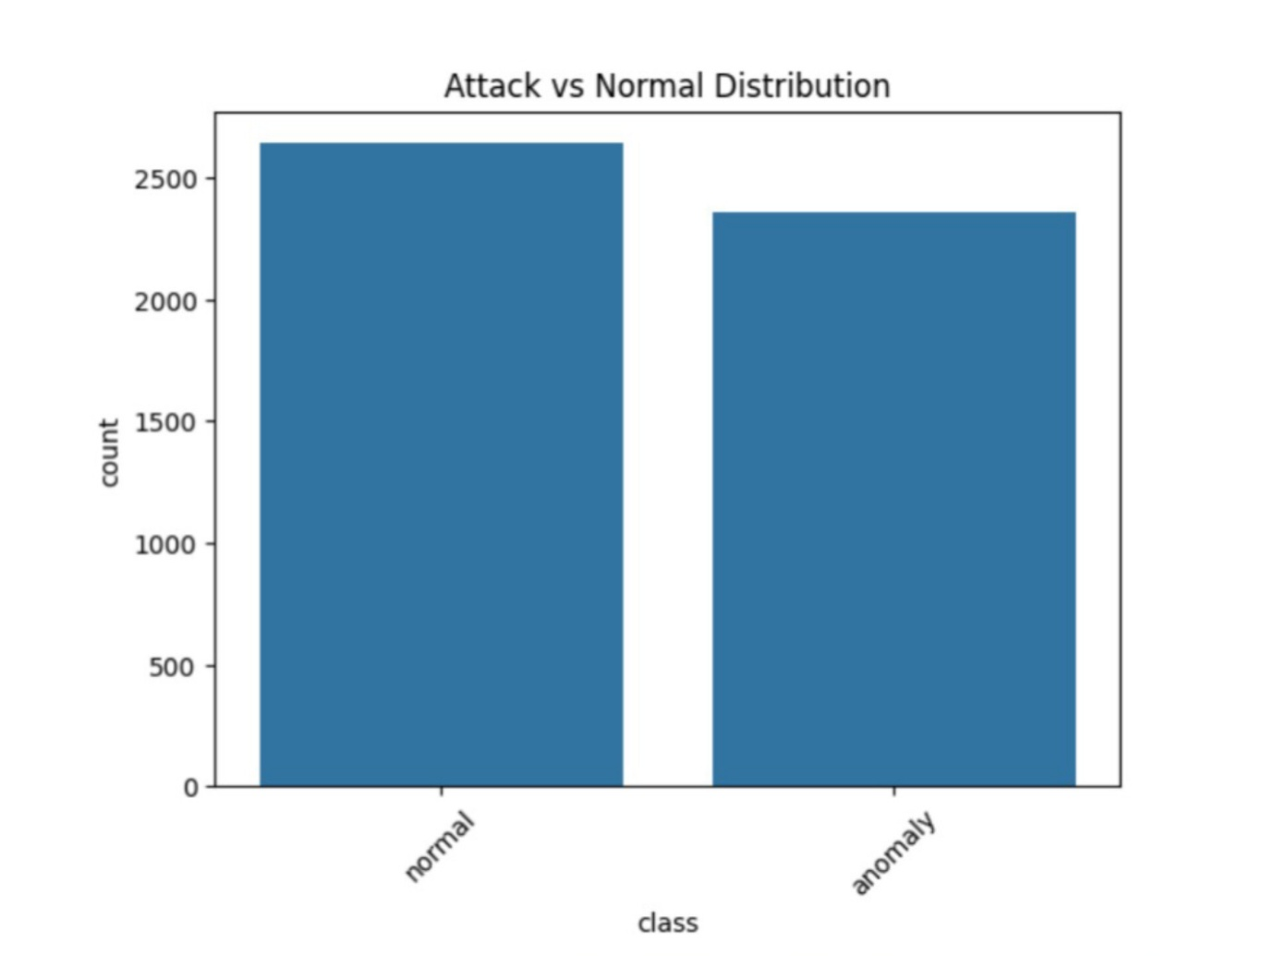

FIG 2: ATTACK VS NORMAL DISTRIBUTION

The class distribution between normal traffic and attack (anomalous) traffic is relatively balanced, with a slightly higher number of normal instances. In the context of a network intrusion detection system, this is advantageous because the model is exposed to sufficient examples of both legitimate and malicious network behavior during training. As a result, the model is less likely to become biased toward normal traffic and can better learn to identify intrusion patterns.

6. References:
Books:
- Artificial Intelligence and Machine Learning – Vinod Chandra S.S.

Online Resources:
- https://www.kaggle.com/datasets/hassan06/nslkdd
- https://en.wikipedia.org/wiki/Machine_learning
- https://scikit-learn.org
- https://www.geeksforgeeks.org

